IO-circuit in which sockets are attached

Emit and On goes hand in hand  
  
if I wrote Io.emit-sending to whole circuit  
if I wrote socket.emit-sending to particular socket

Emit-sends the data (by triggering a method) along with event name which should be same in case of ‘On’  
on -receives that code by callback method

If I have to talk to a particular person then I have to use socket.to.emit(“btn”,hello )

connection(only)  
backend  
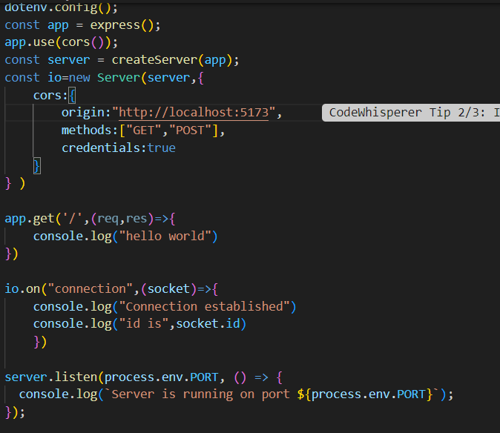

frontend  
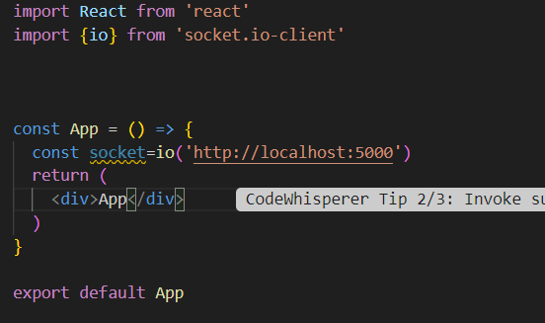

socket.on gets triggered when connection is set it is use to make events  
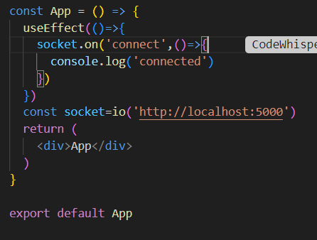

event fired  
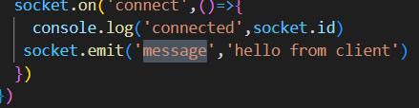  
event caught  
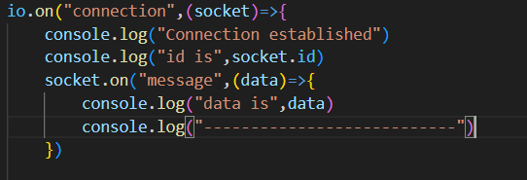  
  
  
broadcasting  
